**Logo Quiz - Official User Manual**

Upon opening the app the MenuActivity will appear. In this activity you can select a level, then press the "Play" button to move to a level. As well there is a switch you can tap to turn music on or off, an intent will show up that will tell you the songs information.

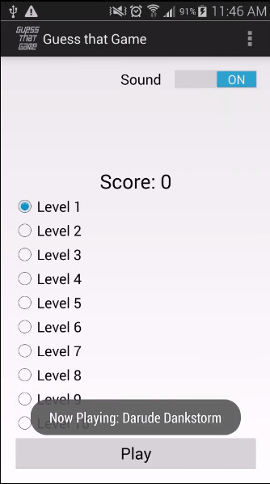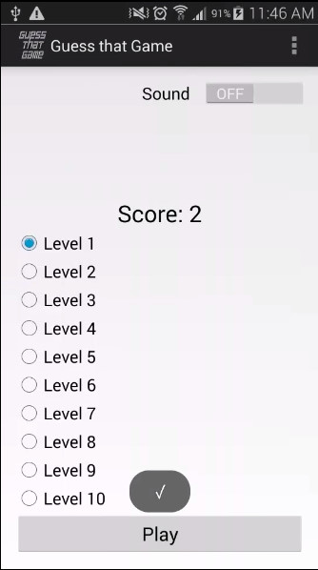

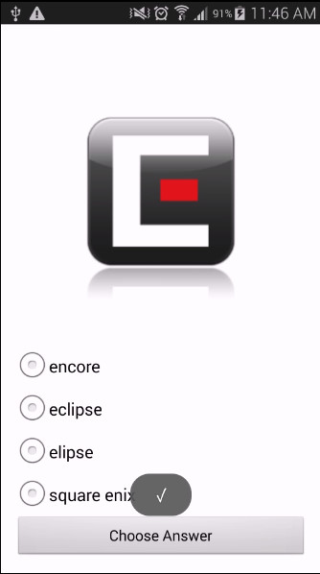Once you press play the GameActivity will open. You will be given a Logo and 4 radiobuttons with answers. You will select what you think the name of the given logo is and press the "submit" button. If you are correct your score will increase by 1 point, if incorrect you will not be rewarded any points. An intent will show up after each answer with either an "x" if wrong or a check mark when right.Upon submitting you will be given a new image and answers. To return to the MenuActivity you can press the back key at anytime or reach the end of the level. When you return to the MenuActivity you will be able to see your updated score.

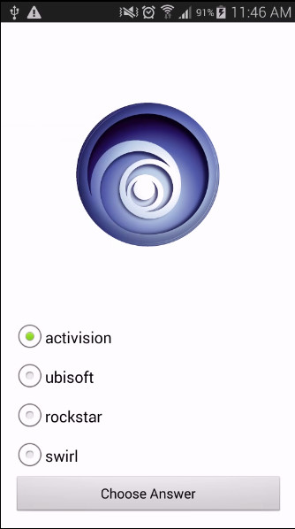

At the MenuActivity you can as well access the HTML and settings activity via the drop down menu at the top of the screen. If you select the HTML option you will be brought to a page featuring Nicholas Cage.

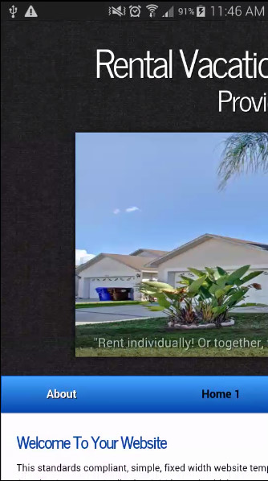

If you select the settings activity you will be brought to the settings page which is currently empty.

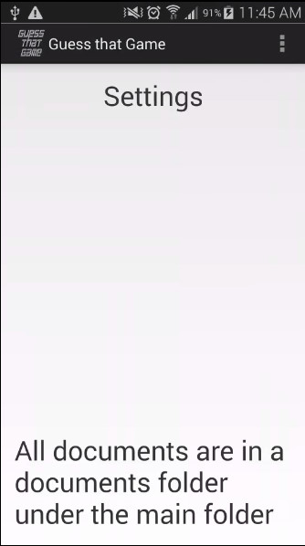

Pressing the back key will return you to the Menu.